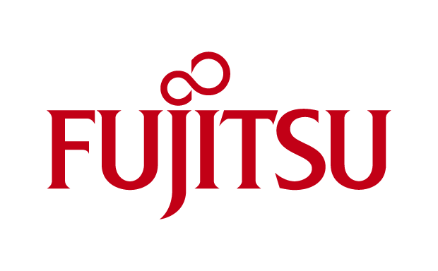
Supplementary terms for Fujitsu Support Packs
in addition to the General terms and conditions for Hardware and Software Support Services of Fujitsu Technology Solutions

- The type and scope of the acquired Fujitsu Support Pack is identified by the original purchase document / delivery note as issued by Fujitsu or the Fujitsu sales partner as well as by the details in the confirmation of Support Pack activation as issued by Fujitsu. Should there be any differences in the details on the original purchase document and the Fujitsu confirmation of Support Pack activation, the customer is requested to contact the Fujitsu person named in the documents immediately.
- The basic mandatory prerequisite for a customer to claim service delivery from Fujitsu on the basis of a Fujitsu Support Pack is the prior activation of the Support Pack in order to bindingly assign the pack to a specific contracted product.
Important: As a general rule the service claim under the Support Pack contract does not cover for service incidents occurring within the first 48 hours after the required activation at Fujitsu. If a certificate (including the activation key) is lost, customer shall have no right to a replacement.
- Upon the purchase of the Support Pack (or in close conjunction thereof) the customer shall receive a Support Pack certificate, which contains the activation key and in which further details about the activation process are described. If the customer does not agree to the activation terms & conditions, the customer is entitled to cancel the Support Pack purchase within 14 days of purchase (date on purchase document / delivery note). The Fujitsu Support Pack activation via the Fujitsu registration procedure has to occur within 30 days of customer purchasing the Support Pack.
- Support Packs can only be acquired and used for new products. This means that at the time of activation of the Support Pack the specific product to be selected for service entitlement must not be older than 120 days (purchase date according to end-customer document/delivery note). Activation of the Support Pack at a later date is only possible if customer is able to prove to Fujitsu beyond reasonable doubt that the specific Support Pack had been allocated to a specific serial number from the start. The burden of proof in this respect shall be borne solely by the customer.
- Upon Support Pack activation, the service entitlement resulting from the Support Pack is assigned to the ID and serial number specified by the customer during activation. The Fujitsu Support Pack may then no longer be transferred to any other hardware or software products.
- Special activation terms & conditions shall apply for Fujitsu Support Packs with 4 hours response time or defined recovery times:
- The service beneficiary is obliged during activation to select and specify the location of the product entitled to the service. A corresponding service entitlement for the contracted product shall in this case only start 14 days after activation and be restricted to the specified location. Customer shall notify Fujitsu prior to moving any contracted hardware product to another location.
The service entitlement for the contracted product at a changed location in turn will only start 14 days after the notification of the change and the new location has been received by Fujitsu. If the contracted product is moved to another location by customer for reasons which either are exclusively within the scope of the customer's sphere of responsibility or which are otherwise within the sole responsibility of the customer, additional costs and modified service levels / response times may have to be borne by the customer as a consequence.

